# 7. ENERGY OF A SYSTEM

## 7.2 Work Done by a Constant Force

**Work**: the work W done on a system by an agent exerting a constant force on the system is the product of the magnitude F of the force, the magnitude Δr of the displacement of the point of application of the force and cosθ , where θ is the angle between the force and displacement vectors [N m = J (Joule)]

W = F Δr cosθ

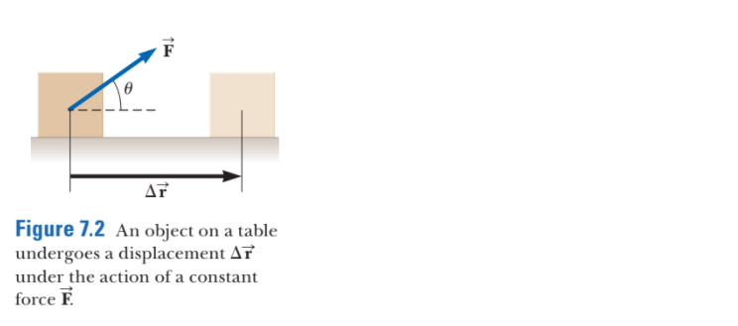

If W is the work done on a system and W is positive, energy is transferred to the

system; if W is negative, energy is transferred from the system.

## 7.3 The Scalar Product of Two Vectors

The scalar product of two vectors is defined as a scalar quantity equal to the product of the magnitudes of the two vectors and the cosine of the angle θ between them

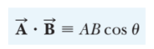

## 7.4 Work done by a Varying Force

**Spring force, Hooke’s law**:

Fs = -kx

## 7.5 Kinetic Energy and the Work–Kinetic Energy Theorem

When energy transfers across the boundary of a system, the amount of energy stored in the system changes

**Kinetic energy**: represents the energy associated with the motion of the particle, is a scalar quantity, same unit as work

(J, Joule)

K = 1/2 mv2

West = Kf - Ki = ΔK

The final kinetic energy of an object is equal to its initial kinetic energy plus the change in energy due to the net work done on it

When work is done on a system and the only change in the system is in the speeds of its members, the net work done on the system equals the change in kinetic energy of the system, as expressed

## 7.6 Potential Energy of a System

**Potential energy**: the potential energy of a system can only be associated with specific types of forces acting between members of a system. The amount of potential energy in the system is determined by the *configuration* of the system

**Gravitational potential energy**: [J, Joules]

Ug = mgh

Same unit of measurement of work and kinetic energy

Gravitational potential energy depends only on the vertical height of the object above the surface of the Earth

**Elastic potential energy**:

Us = 1/2 kx2

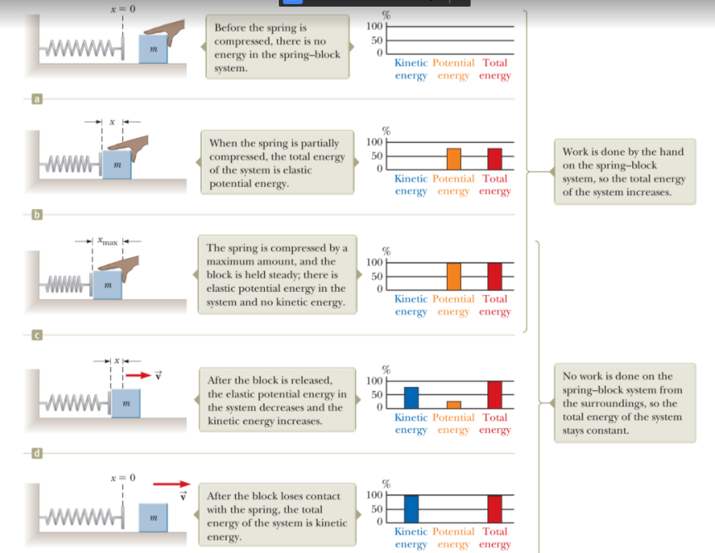

## 7.7 Conservative and Nonconservative Forces

**Conservative forces**:

* The work done by a conservative force on a particle moving between any two points is independent of the path taken by the particle
* The work done by a conservative force on a particle moving through any closed path is zero. (A closed path is one for which the beginning point and the endpoint are identical)

Gravitational force and the force of an ideal spring exert on any object attracted to the spring are conservative forces

**Nonconservative forces**:

A force that does not satisfy properties 1 and 2 above

**Mechanical energy**:

Emech = K+U

## 

